Improving annual ryegrass control with glyphosate: interactions between water quality, water rate and adjuvants, Narromine 2021.
Trial code: GAWE07221
Season/year: Autumn, 2021
Location: Narromine
Trial partners: Richard Tink and Matthew Shephard

Keywords
Annual ryegrass, Lolium rigidum, resistance, knockdown, glyphosate, wetter, surfactants, GOWE057, water quality, Narromine.

Key findings
- The highest number of surviving ARG were where a high rate of bore water was used.
- Better results were achieved with bore water when it was ameliorated with SOA and where the water rate was reduced.
- Adding LI700 did not improve control.
- Where reverse osmosis was used on bore water, the surviving weed numbers were no different from where rainwater was used.

Background
Water quality can impact herbicide efficacy via several pathways such as pH, hard water, bicarbonates and colloids to name a few. Hard water is defined as being high in dissolved minerals, largely calcium and magnesium. Growers generally have limited on-farm water sources and access to quality water for spraying can be finite. Poor water quality can sometimes be managed using wetters and adjuvants, other options include installation of large water tanks for rainfall collection and the use of reverse osmosis machines.
The impact of poor quality water on spray efficacy is not well documented, due to the vast range of water sources used. Spray opportunities in the optimal window are narrowing due to such factors as spray drift concerns, increasing farm size, labour shortages etc. This can result in spraying under sub optimal conditions. The herbicide efficacy using poor quality water may be part reason for increasing reports of spray failures.
Control of glyphosate resistant annual ryegrass (ARG) can be rate responsive and weeds with weak glyphosate resistance mechanisms can often be killed with higher label rates. Increasing glyphosate rates may lead to more effective control by “counteracting poor application, improving control of older plants, stressed plants or overcoming reduced efficacy caused by using poor quality water or treating plants covered by dust. Higher label rates can also improve glyphosate activity of plants exposed to high temperatures such as in early autumn or late spring”.
Herbicide resistance surveys conducted by Grain Orana Alliance (GOA) have shown increasing resistance. It is well established that ARG is rate responsive to glyphosate. The use of poor quality water on resistant populations may also further impair glyphosate efficacy.
Glyphosate is generally poorly absorbed by the plant with many commercially available glyphosate formulations adding surfactants or adjuvants to improve product performance. These additives aid in droplet retention and absorption by the plant. Despite the inclusion of these surfactants commercially, additional of other surfactants is common. Wetter TX is most commonly recommended on various glyphosate product labels suggesting improvement in ARG control under specific circumstances (i.e. Roundup Ultra®Max recommendation to add in late winter and spring). However, there are also a range of alternate surfactants available.

Aim
This trial will investigate
- Effect of poor quality water on the efficacy of glyphosate on ARG.
- Whether increasing the water rate changes efficacy.
- Whether wetter or additives can improve poor quality water.
- Whether increasing the chemical rate can overcome poor water quality.
- Whether poor quality water ameliorated by reverse osmosis improves performance.

Methods
- The trial site was selected as it had suspected annual ARG resistance to glyphosate, and a visible ARG population (refer Appendix, Figure 2).
- Small plot, randomised complete block design trial, with 4 replicates.
- Treatments were applied using an ATV mounted boom.
- All treatments were applied using the same nozzle and spray pressure set-up.
- Water rates: 50L/ha and 100L/ha.
Results were analysed by ANOVA and results compared by using LSD method with a 95% confidence interval. Any references to differences between treatments should be assumed to be statistically different unless otherwise stated.
Table 1. Trial site details
Establishment date | Autumn, 2017
Soil type | Red clay loam
Previous crop | Wheat
ARG resistance status | Detailed in appendix- suspected resistance

Table 2. Treatment list.
Water source | Adjuvant | Water rate | Glyphosate rate
 |  | L/ha | gAI/ha glyphosate
Bore - RO | nil | 100 | 285
Bore water | SOA | 100 | 285
Bore water | SOA-LI700 | 100 | 285
Bore water | nil | 100 | 285
Bore water | LI700 | 100 | 285
Bore water | nil | 50 | 285
Rainwater | nil | 100 | 285
Rainwater | SOA-LI700 | 100 | 285
Rainwater | SOA | 100 | 285
Rainwater | nil | 50 | 285
Bore water | nil | 100 | 570
Rainwater | nil | 50 | 570
UTC | nil | UTC | UTC
lsd

Table 3. Application record
First application | Date applied | 14/04/2021 | Temp (°C) | Wind (km/h) | Wind Direction | Humidity (%)
First application | Start time | 0715 | 12 | 3-6 | NE | 61.7
First application | Finish time | 0800 | Δt | 3.9 | % Cloud | 0
First application | Water rate (L/ha) | 50/100L | Nozzle | AIXR015 | Pressure | 3
First application | Equipment | ATV | Speed | 14/7K

Results
Full results are detailed in the table in the appendix at the end of the document.
Water rate:
There was a significant effect of water rate. The effect was greatest where poor quality water was used, for example bore water at 100 L/h and the lower glyphosate rate of 285 gAI/ha.
There ~27 plants/m² surviving ARG plants compared to ~9 plants/m² where 50 L/ha bore water was used.
Water quality
Where bore water was used at 100 L/ha at the lower glyphosate rate of 285 gAI/ha there were ~27 plants/m² surviving ARG plants compared to 4 plants/m² and 3 plants/m² for reverse osmosis bore water and rainwater respectively.
Adjuvants
Where SOA was added to bore water at the high water rate and lower glyphosate rate of 285 gAI/ha, ARG numbers were lower (~ 3 plants/m² compared to ~27 plants/m²).
Glyphosate rate
The higher rate of glyphosate (570 gAI/ha) provided the best reductions in the ARG populations. Both treatments reduced the population to below 1 plant/m², regardless of water quality.
Figure 1. ARG counts after the application of various water sources, two glyphosate rates and water sources and a small selection of adjuvants. Assessed 34 days after initial application.

Discussion
Prior to the establishment of the trial, significant rainfall events in March (approximately 160 mm) ensured good weed germination. At the time of the initial application, there was a moderately high population of ARG with close to 100 plants/m² in the untreated control (UTC). Plants were at an early tillering stage and not visibly stressed.
The bore water used in this trial was known to be low quality and the grower had suspected it was affecting the herbicide efficacy, instaling a reverse osmosis filter. Filtered and unfiltered water from this bore was tested as was the rainwater (results are in the annex). The unfiltered bore water had high Electrical Conductivity (a measurement of salinity), high bicarbonate levels, high water hardness and very high total dissolved ions (it also had elevated levels of sodium, chloride, calcium and magnesium). Of these, remediation of hard water, typically with SOA, is recommended when using glyphosate products.
For most treatments the reduction in ARG populations was in the range of what might be considered a commercially viable application, i.e., where greater than 90% plant reduction has been achieved.
The 2 treatments that resulted in the highest number of surviving ARG were where a high rate of bore water was used. It is often hypothesised that bore water (or low-quality water) can impact herbicide efficacy, these results support that theory. Adding SOA to the bore water helped ameliorate the poor quality of the water. Adding LI700 did not improve control, and in this experiment resulted in more survivors. Using the same filtered water significantly reduced the numbers of surviving ARG plants. Reducing the water rate reduced the number of survivors when using the unfiltered bore water, however still had more survivors than all other treatments. Using lower water rates did not make a significant difference to the efficacy when using rainwater.
Adding more glyphosate to the bore water also reduced the number of surviving ARG and had a better result than where the bore water was ameliorated with SOA (and where the water rate was reduced).
Resistance testing did show high levels of resistance at the lower rates (80% survivors where Roundup Ultra®MAX was applied at 0.5 L/ha) however this was not necessarily reflected in the paddock where very few survivors were observed.
This trial was conducted under conditions that would generally be considered ideal for paddock spraying. It was conducted early in the morning, in cool temperatures when plants were unstressed and actively growing. Under conditions that are less than ideal (heat, plant stress, wind, etc), the issues highlighted in this trial with poor quality water might be magnified.

Conclusion
- Know the glyphosate resistance status of ARG populations to determine rates required for acceptable control.
- Growers should test water intended for spraying for quality. If the water is hard, it may be ameliorated by the addition of SOA however increasing the glyphosate rate may provide a better outcome.
- Reducing the spray water volume may also improve the level of control, but it is recommended to either ameliorate the water and/or increase the glyphosate rate. Filtering water via reverse osmosis is an option and may be an economic alternative to the use of SOA or other adjuvants.

Acknowledgements
Research undertaken as part of this project is made possible by the significant contributions of growers through both trial cooperation and the support of the Grains Research and Development Corporation (GRDC), the authors would like to thank them for their continued support. Special thanks go out to Richard Tink who hosted this trial and Matthew Shephard for his input.

DISCLAIMER — TECHNICAL
This report has been prepared in good faith based on information available at the date of publication without any independent verification. The GRDC, and GOA do not guarantee or warrant the accuracy, reliability, completeness of currency of the information in this publication nor its usefulness in achieving any purpose.
Readers are responsible for assessing the relevance and accuracy of the content of this publication. The GRDC and GOA will not be liable for any loss, damage, cost or expense incurred or arising by reason of any person using or relying on the information in this publication.
Products may be identified by proprietary or trade names to help readers identify types of products, but this is not, and is not intended to be, an endorsement or recommendation of any product or manufacturer referred to. Other products may perform as well or better than those specifically referred to.
Following is a report on a scientific experiment. It may contain some herbicide treatments that are not registered for the situation, manner or rate at which they are used in this trial. This document or anything else resulting from, construed or taken from this or by GOA or its representatives should not be taken as a suggestion, recommendation or endorsement for unregistered herbicide use.

Appendix –
Figure 2- Resistance ratings of the ARG population.

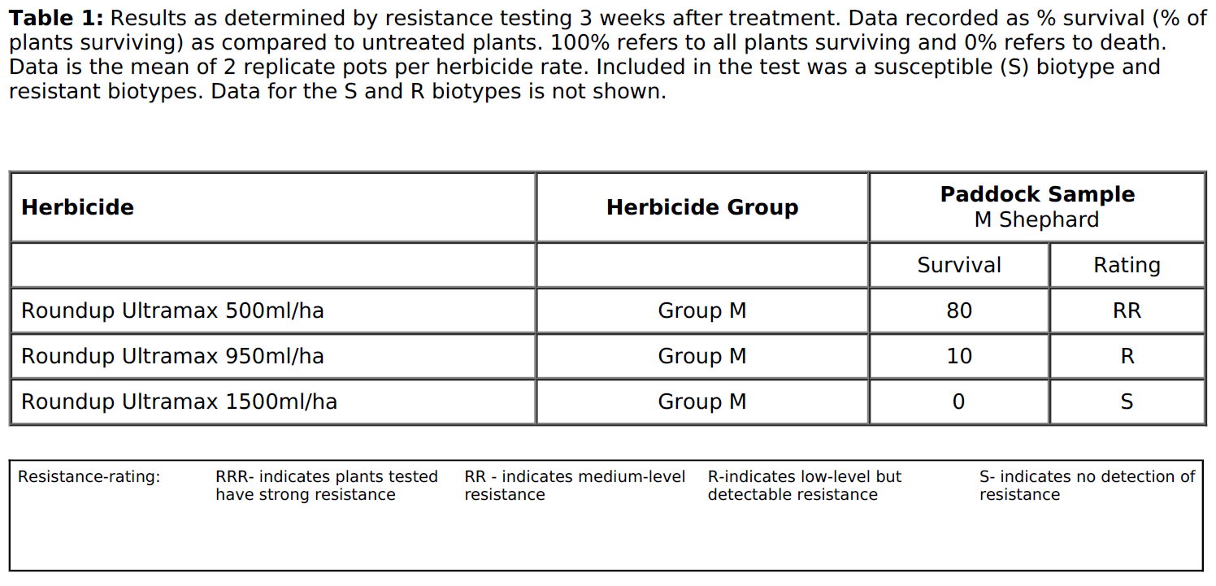

Ryegrass counts 30 days after treatment application
Water source | Adjuvant | Water rate | Glyphosate rate | ARG counts | LSD
 |  | L/ha | gAI/ha glyphosate | Plants/m2
Bore - RO | nil | 100 | 285 | 4.1 | e
Bore water | SOA | 100 | 285 | 2.6 | e
Bore water | SOA-LI700 | 100 | 285 | 3.5 | e
Bore water | nil | 100 | 285 | 27.3 | c
Bore water | LI700 | 100 | 285 | 49.5 | b
Bore water | nil | 50 | 285 | 8.9 | d
Rainwater | nil | 100 | 285 | 3.3 | e
Rainwater | SOA-LI700 | 100 | 285 | 3.6 | e
Rainwater | SOA | 100 | 285 | 3.9 | e
Rainwater | nil | 50 | 285 | 1.6 | ef
Bore water | nil | 100 | 570 | 0.3 | fg
Rainwater | nil | 50 | 570 | 0.0 | g
UTC | nil | UTC | UTC | 117.1 | a
lsd |  |  |  | 0.9

https://grdc.com.au/resources-and-publications/grdc-update-papers/tab-content/grdc-update-papers/2015/02/optimising-the-impact-of-glyphosate
SILO Data Drill for Lat, Long: -32.45 147.90 (DECIMAL DEGREES), 32 27'S 147 54'E STANDARD, Queensland Government Department of Environment and Science

