The effect of phosphorous rate on canola sown outside of the planting window.
Trial code: GAMA010211
Season/year: Winter 2021
Location: Jedburgh, Warren
Trial partners: Peter Brigden and Gus O'Brien

Keywords
GAMA010, canola, late sowing, variety, population, TT, triazine tolerant, Clearfield, conventional, phosphorous rate

Key findings
- Choosing a high yielding variety, targeting higher plant populations and ensuring adequate P levels improves the probability of achieving a profitable late sown canola crop.
- Sowing in the recommended window when possible is better than sowing late.
- Increasing target populations from 10 to 30 plants/m² increased yields, regardless of variety or time of sowing.
- There were considerable yield differences between varieties, hybrids outyielded conventionals.
- At both time of sowings the medium population had the highest yield.
- Diamond had the highest yield (over 3 t/ha) while Stingray had the lowest (less than 2.5 t/ha)
- There was no P response.

Background
Ideal sowing windows for canola are well established and there has been a recent trend towards sowing early, as recent GRDC funded trials have shown yield improvements. However, delayed seasonal breaks (after the 10 May) are often quite common in Central West NSW, causing many growers to either reducing canola areas or removing the crop from the rotation with concerns over low profitability and possible crop failure.
The removal of canola from the rotation has many flow-on issues including disease and weed management as well as increased income risk through loss of commodity diversification. Clearly there are advantages to maintaining canola in the rotation with later autumn breaks but are there agronomic levers that can be manipulated to optimise the performance of late sown canola.
Trail work by Grain Orana Alliance (GOA) in the drought conditions of 2018 showed that hybrid Clearfield lines substantially out yielded similar maturity open pollinated TT lines when sown late. This may be due to the enhanced early growth rates and robustness of the hybrid lines, enabling biomass accumulation with minimal rainfall compared to the TT lines which could not. This work also demonstrated that hybrid canola was as good, as or in many cases, a better option for late sowing than pulses or cereals.
This work demonstrated that further investigation of varietal choice, both maturity and crop type (hybrid versus open pollinated) might give growers more confidence to keep canola in the rotations. Having robust plant populations is likely to become more important as sowing becomes later, as there is less time for compensatory growth and is worth further study.
This trial investigates changing variety, both maturity length and production systems, and the interaction with plant population to improve performance in late sown canola.

Aim
To compare crop performance of a range of canola varieties with differing maturities and or production systems, sown with various rates of phosphorous (P) at low, medium and high plant populations within the optimal sowing window with the same treatments sown later, outside the optimal window.

Methods
Trial details
Establishment date |  |  | Autumn 2021
Sowing configuration |  |  | 275 mm row spacing, knife point press wheel  150 kg/ha urea.  P as treatment (see below), applied immediately before sowing (IBS).
Paddock history | 2020 wheat |  |  |  | Soil test | Nitrogen (N)  (kg/ha) | Colwell P  (ppm) | Sulfur  (ppm)
 | 2019 (drought) |  |  |  | 0-10cm | 36 | 33 | 3
 | 2018 (drought) |  |  |  | 10-90cm | 120 | - | 7
Sowing timings | Time of sowing (TOS) |  |  | Harvest |  | Targeting TOS 2 to be >3 weeks outside the latest timing, as recommended by the NSW DPI Winter crop variety sowing guide
Sowing timings | TOS 1 | 27/4/2021 |  | 9/11/2021
Sowing timings | TOS 2 | 25/5/2021 |  | 18/11/2021
Treatments
Phosphorous: P @ 0, 5, 10, 15, 20, 25 and 30 kg/ha applied to the medium population of Diamond
Varieties and target plant population (plant/m²): varieties common to the region, suiting later sowing | Variety |  | 43Y92 CL |  | 45Y93 CL | ATR Stingray® | Diamond | Hyola® 350 TT | HyTTec®  Trophy
 | Type |  | Imidazolinone tolerant hybrid |  |  | Triazine tolerant, open pollinated | Conventional hybrid | Triazine tolerant, hybrid
 | Phenology |  | Mid-fast |  | Mid-slow | Fast | Fast | Fast | Mid-fast
 | Maturity |  | Early |  | Mid | Early | Early | Early | Early - early Mid
 | Target population (plants/m2) |  | Sowing rate (kg/ha)
 | 10 |  | 1.2 |  | 1.0 | 0.5 | 0.8 | 1.2 | 1.0
 | 30 |  | 3.5 |  | 3.0 | 1.6 | 2.5 | 3.5 | 2.9
 | 60 |  | 6.9 |  | 6.1 | 3.1 | 5.0 | 7.0 | 5.8
Trial design | Type: small plot (~12m x 2m)  Design: split randomized block  Replication: 4 |  |  |  | Analysis ASREML – randomized split block with 3 factors.  Tested to a 95% confidence interval
Observations and measurements | - Soil testing  - Plant establishment  - Vegetation index (2) NDVI  - Grain yield and quality

The planting date represented by the red bars on Figure 1 show that TOS 1 is towards the end of the ideal window for most varieties. While TOS 2 is >3 weeks later than the ideal sowing window for most varieties and well outside district practice in the central west of NSW.
￼
Table 1: Warren rainfall for 2021 and long-term average (LTA).
Month | Jan | Feb | March | April | May | June | July | Aug | Sept | Oct | Nov | Dec | TOTAL
2021 | 32 | 81 | 254 | 0 | 30 | 58 | 42 | 28 | 53 | 20 | 92 | 52 | 742
LTA | 49 | 46 | 42 | 35 | 36 | 35 | 30 | 30 | 30 | 35 | 36 | 44 | 448
Variety and phenology

Results
Figure 1. Sowing windows and actual TOS dates
Plant establishment: Plant establishments was lower for TOS 1 than for TOS 2. Satisfactory establishment was achieved for all varieties, with differences between the populations within a variety and TOS, with the exceptions of 45Y93CL where the low and medium populations were similar and for the 43Y92CL where the medium and high populations were similar.
Yield
There was a yield response to all the factors included in this trial (Figure 2)
- Sowing later (TOS 2) had a lower yield than TOS 1.
- Increasing target populations from low to medium (10 to 30 plants/m²) increased yields, regardless of variety or TOS
- Highest yields were achieved at the medium population; the high population ad better yields than the low population.
- Diamond had the highest yield (over 3 t/ha) while Stingray had the lowest (less than 2.5 t/ha)
- There was no P response.
Figure 2. Canola yields as influenced by TOS, plant populations, variety and P rate. Results with the same letter within each factor are not significantly different.
Yield and interactions between population, variety, TOS and P rate
There were interactions between the treatments
Population and variety (Figure 3)
- For all varieties the lowest yield was at the low population, generally yields were highest at the medium population, though 45Y93CL, Diamond and ATR Stingray® yields were similar at the high population.
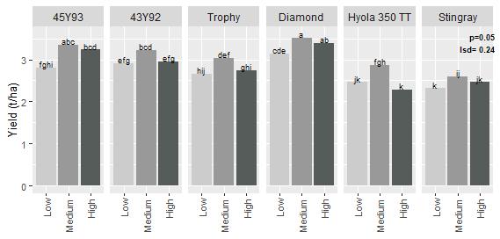
Figure 3. Canola yields as influenced by variety and population. Results with the same letter within each facet are not significantly different.
Timing and variety (Figure 4)
- At TOS 1, 45Y93CL, 43Y92CL and Diamond all had the highest yields and were not different to each other. Hyola® 350TT had the lowest yield.
- At TOS 2:
  - Diamond had the highest yield, followed by 45Y93CL.
- 43Y92CL, HyTTec® Trophy and Hyola® 350TT were not different to each other
- ATR Stingray® had the lowest yield.
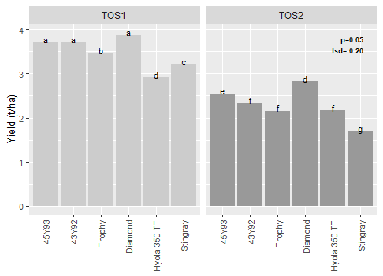
Figure 4. Canola yields as influenced by timing and variety. Results with the same letter within each facet are not significantly different.

Timing and population
- At both TOS’s the medium population had the highest yield.
- The high population was not different to the low population at TOS2
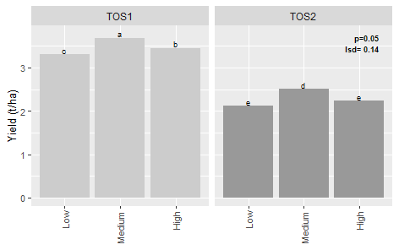
Figure 5. Canola yields as influenced by timing and population. Results with the same letter within each facet are not significantly different.

P rate and timing (Figure 6)
- There was very no response to applied P.
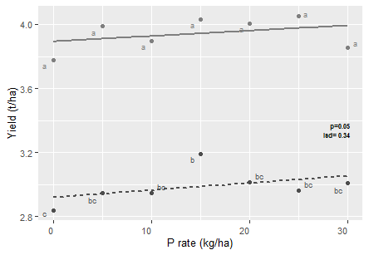
Figure 6. Canola yields as influenced by TOS and phosphorus rate. Results with the same letter within each facet are not significantly different.

Discussion
2021 was an above average rainfall year, which proved to be good for canola production at Warren (Table 1), although sowing conditions at the TOS 1 were drying off and some varieties we struggled to achieve the desired plant populations.
As expected, TOS had the greatest impact on yields, with the early timing (TOS 1) outyielding the later sown crop (TOS 2) by more than 1 t/ha. What was not very well known was the influence population might have on TOS 2. It was considered that a high population may be more important as the time for compensatory growth is reduced. In this case having a medium population was the optimal sowing rate at both TOS’s. The earlier, TOS 1 had a much lower establishment due the dry sowing conditions than TOS 2, despite this, yields were still optimised at the medium population, and exceeded the TOS 2 yields, showing the ability of canola to compensate if time allows. At both timings a target population of 10 plants/m² was too low for optimal yield. There was not much benefit from increasing the population above 30 plants/m².
There were big varietal responses in yield. Diamond performed very well and when it was planted outside its recommended window, yielding close to 3 t/ha at the medium sowing rate (target of 30 plants/m²). One reason that growers lack confidence to back late sowing of canola is that experiences have been variable, possibly due to the use of open pollenated TT varieties, that have a known low vigour (10-15% lower yields than conventional varieties).
There was a relatively mild and wet spring finish to the season. This may have suited some of the longer varieties and in a tighter finish, the quicker varieties such as Stingray may have performed better. At least one study concluded that yield is very closely correlated to biomass at nearly all stages of crop growth. Field observations showed that the higher yielding varieties such as Diamond had much higher early vegetation compared to Stingray at the target population of 30 plants/m², this trend was also reflected in yield. This might suggest that varieties that accumulate the early biomass have the higher yield potential even under tough finishes.
The use of better genetics and ensuring adequate plant populations could remove a much of the risk associated with late sown canola.

Conclusion
Canola can be maintained in the rotation in late sowing scenarios. Growers' confidence can be increased by sowing varieties with higher yield potential and ensuring that populations are greater than 10 plants/m².

Acknowledgements
The research undertaken as part of this project is made possible by the significant contributions of growers through both trial cooperation and the support of the Grains Research and Development Corporation (GRDC), the authors would like to thank them for their continued support. Special thanks go out to Gus O’Brien and family from Warren who hosted this trial.

DISCLAIMER — TECHNICAL
This report has been prepared in good faith based on information available at the date of publication without any independent verification. The GRDC and GOA do not guarantee or warrant the accuracy, reliability, completeness of currency of the information in this publication nor its usefulness in achieving any purpose.
Readers are responsible for assessing the relevance and accuracy of the content of this publication. The GRDC and GOA will not be liable for any loss, damage, cost or expense incurred or arising by reason of any person using or relying on the information in this publication.
Products may be identified by proprietary or trade names to help readers identify types of products, but this is not, and is not intended to be, an endorsement or recommendation of any product or manufacturer referred to. Other products may perform as well or better than those specifically referred to.

Appendix: Results table
TOS | Variety | Population | P rate (kg/ha) | Plant establishment (plants/m²) |  | Yield (t/ha) |  | Oil (%)
TOS1 | 43Y92 | High | 20 | 30.7 | klm | 3.67 | bcdefgh | 43.5 | klmnopq
TOS1 | 43Y92 | Low | 20 | 9.5 | rst | 3.53 | efghij | 44.3 | cdefghijk
TOS1 | 43Y92 | Medium | 20 | 24.0 | mnopq | 3.93 | abc | 43.9 | ghijklmn
TOS1 | 45Y93 | High | 20 | 34.3 | jkl | 3.79 | abcdef | 43.7 | ijklmno
TOS1 | 45Y93 | Low | 20 | 12.3 | rst | 3.44 | ghijk | 44.1 | efghijklm
TOS1 | 45Y93 | Medium | 20 | 19.0 | nopqr | 3.89 | abcd | 44.0 | fghijklmn
TOS1 | Diamond | High | 20 | 44.3 | ghi | 4.02 | a | 44.5 | cdefgh
TOS1 | Diamond | Low | 20 | 10.5 | rst | 3.57 | defghi | 45.0 | abcd
TOS1 | Diamond | Medium | 20 | 26.3 | lmno | 4.00 | ab | 45.5 | a
TOS1 | Hyola 350 TT | High | 20 | 56.5 | ef | 2.55 | qrst | 44.3 | cdefghij
TOS1 | Hyola 350 TT | Low | 20 | 11.5 | rst | 2.84 | nopq | 44.7 | abcdefg
TOS1 | Hyola 350 TT | Medium | 20 | 24.3 | mnop | 3.35 | hijkl | 44.4 | cdefghi
TOS1 | Stingray | High | 20 | 32.3 | klm | 3.22 | jklm | 44.5 | cdefghi
TOS1 | Stingray | Low | 20 | 5.8 | t | 3.15 | klmn | 44.2 | defghijk
TOS1 | Stingray | Medium | 20 | 15.8 | pqrs | 3.28 | ijklm | 44.6 | bcdefg
TOS1 | Trophy | High | 20 | 39.3 | ijk | 3.46 | fghijk | 44.5 | cdefghi
TOS1 | Trophy | Low | 20 | 8.5 | st | 3.29 | ijklm | 44.1 | efghijklm
TOS1 | Trophy | Medium | 20 | 25.8 | lmno | 3.66 | cdefgh | 44.0 | ghijklmn
TOS2 | 43Y92 | High | 20 | 71.7 | cd | 2.23 | tuvwx | 43.3 | mnopqr
TOS2 | 43Y92 | Low | 20 | 14.0 | qrst | 2.27 | tuvw | 42.3 | tu
TOS2 | 43Y92 | Medium | 20 | 39.8 | hijk | 2.50 | qrstu | 42.6 | qrstu
TOS2 | 45Y93 | High | 20 | 83.5 | bc | 2.67 | pqrs | 42.8 | pqrstu
TOS2 | 45Y93 | Low | 20 | 12.5 | rst | 2.17 | uvwx | 41.5 | v
TOS2 | 45Y93 | Medium | 20 | 48.0 | fghi | 2.81 | nopq | 42.4 | stu
TOS2 | Diamond | High | 20 | 93.0 | ab | 2.75 | opqr | 43.6 | jklmnop
TOS2 | Diamond | Low | 20 | 17.3 | opqrs | 2.70 | opqrs | 43.2 | nopqrs
TOS2 | Diamond | Medium | 20 | 45.5 | ghi | 3.02 | lmno | 43.3 | lmnopqr
TOS2 | Hyola 350 TT | High | 20 | 101.4 | a | 2.02 | wxy | 42.6 | rstu
TOS2 | Hyola 350 TT | Low | 20 | 15.5 | pqrst | 2.09 | vwx | 42.4 | stu
TOS2 | Hyola 350 TT | Medium | 20 | 49.5 | fgh | 2.38 | stuv | 42.6 | qrstu
TOS2 | Stingray | High | 20 | 69.8 | d | 1.70 | yz | 42.7 | qrstu
TOS2 | Stingray | Low | 20 | 11.4 | rst | 1.48 | z | 42.1 | uv
TOS2 | Stingray | Medium | 20 | 30.5 | klm | 1.90 | xy | 42.2 | tuv
TOS2 | Trophy | High | 20 | 62.7 | de | 2.03 | wxy | 42.1 | uv
TOS2 | Trophy | Low | 20 | 13.5 | rst | 2.03 | wxy | 42.7 | qrstu
TOS2 | Trophy | Medium | 20 | 44.8 | ghi | 2.42 | rstuv | 42.6 | rstu
TOS1 | Diamond | Medium | 20 | 26.3 | lmno | 4.00 | ab | 45.5 | a
TOS1 | Diamond | Medium | 0 | 31.5 | klm | 3.78 | abcdefg | 44.9 | abcdef
TOS1 | Diamond | Medium | 5 | 26.5 | lmno | 3.99 | abc | 45.0 | abcd
TOS1 | Diamond | Medium | 10 | 28.8 | lmn | 3.89 | abcd | 45.5 | ab
TOS1 | Diamond | Medium | 15 | 24.5 | lmnop | 4.03 | a | 44.5 | cdefgh
TOS1 | Diamond | Medium | 25 | 29.3 | lm | 4.05 | a | 44.9 | abcde
TOS1 | Diamond | Medium | 30 | 31.0 | klm | 3.85 | abcde | 45.1 | abc
TOS2 | Diamond | Medium | 20 | 45.5 | ghi | 3.02 | lmno | 43.3 | lmnopqr
TOS2 | Diamond | Medium | 0 | 47.3 | fghi | 2.84 | nopq | 44.2 | efghijkl
TOS2 | Diamond | Medium | 5 | 47.3 | fghi | 2.94 | mnop | 44.1 | defghijklm
TOS2 | Diamond | Medium | 10 | 49.5 | fgh | 2.95 | mnop | 44.0 | fghijklmn
TOS2 | Diamond | Medium | 15 | 53.8 | efg | 3.19 | klm | 43.6 | jklmnop
TOS2 | Diamond | Medium | 25 | 44.0 | ghij | 2.96 | mnop | 43.7 | hijklmno
TOS2 | Diamond | Medium | 30 | 45.0 | ghi | 3.01 | lmnop | 43.0 | opqrst
lsd | lsd | lsd | lsd | 10.2 |  | 0.34 |  | 0.8

Queensland Government. (2021). SILO Gridded Climate Data. Retrieved 2025 from https://www.longpaddock.qld.gov.au/silo/
2 Adapted from “Winter Crop Variety Sowing Guide 2021”, NSW DPI
GrowNote-Canola-North-4-Physiology.pdf https://grdc.com.au/__data/assets/pdf_file/0031/369274/GrowNote-Canola-North-4-Physiology.pdf
Zang et al 2016 CSIRO PUBLISHING | Crop and Pasture Science

